PRODUCT REVIEW AND RATING MANAGEMENT SYSTEM
PURPLLE ONLINE BEAUTY SHOPPING

- Introduction

The Purplle Online Beauty Shopping Database Management System is designed to manage product reviews and ratings provided by customers. This week focuses on creating and managing the Rating table. The system stores customer ratings for products and uses SQL queries and aggregate functions to calculate average ratings and identify highly rated products.

- Objectives
The main objectives of this week are:
- To create the Rating table.
- To store customer ratings for products.
- To retrieve product rating details.
- To calculate average product ratings using aggregate functions.
- To identify highly rated products.
- To generate product rating reports.
- Database design

  - Review Table
Attribute | Data Type | Description
Review_ID | NUMBER | Unique ID for each review. Primary Key
Customer_ID | NUMBER | Identifies the customer who gives the review. Foreign Key
Product_ID | NUMBER | Identifies the product being reviewed. Foreign Key
Review_Text | VARCHAR2(500) | Stores the customer's written feedback about the product.
Review_Date | DATE | Stores the date on which the review was submitted.

  - Rating Table
Attribute | Data Type | Description
Rating_ID | NUMBER | Unique ID for each rating. Primary Key
Customer_ID | NUMBER | Identifies the customer who gives the rating. Foreign Key
Product_ID | NUMBER | Identifies the product being rated. Foreign Key
Rating | NUMBER(2,1) | Stores the product rating from 1 to 5.
Rating_Date | DATE | Stores the date on which the rating was given.

- Table Relationships

Customer → Rating
CUSTOMER (1) ─────────── (M) RATING

Customer_ID (PK) → Customer_ID (FK)
One customer can give ratings for multiple products.

PurplleProduct → Rating
PURPLLEPRODUCT (1) ───── (M) RATING

Product_ID (PK) → Product_ID (FK)
One product can receive ratings from multiple customers.

- Table Creation

  - Create Review Table

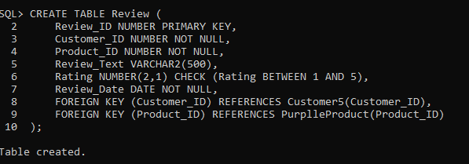

  - Create Rating Table

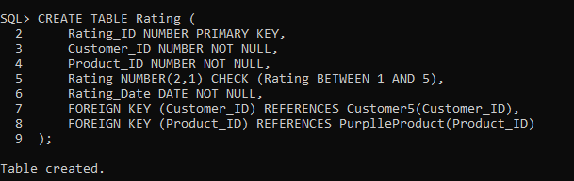

- Review Data Insertion

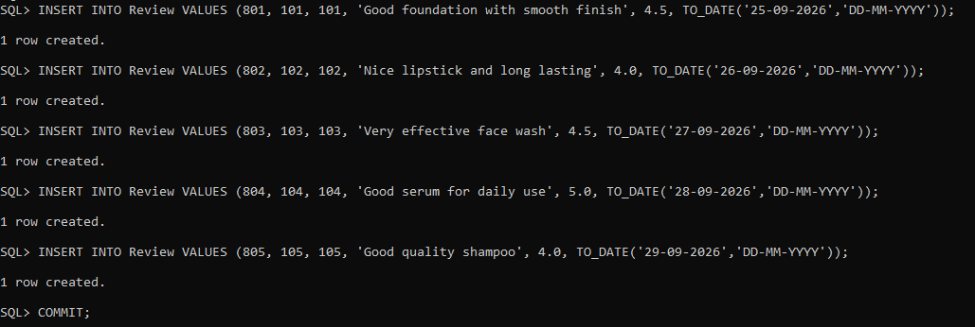

- Rating Data Insertion

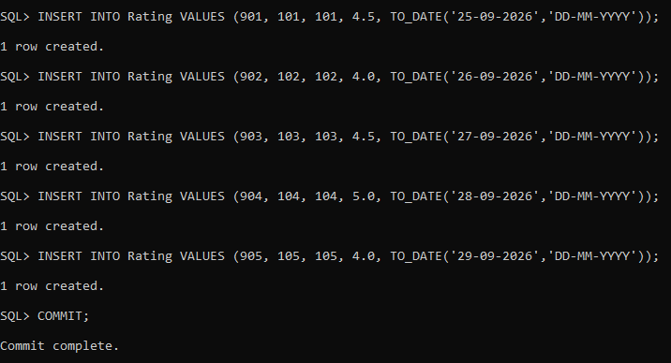

- Data Retrieval

  - Display Review Records

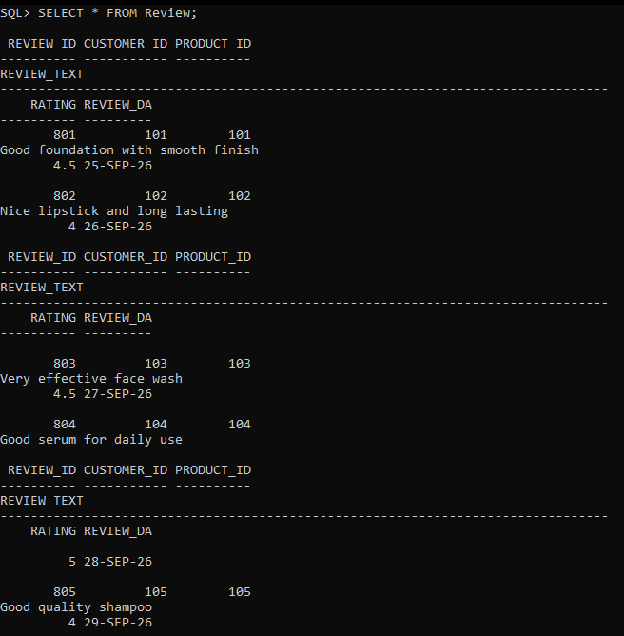

8.2 Display Rating Records

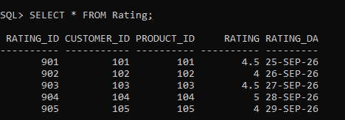

- Retrieve Product Review Details

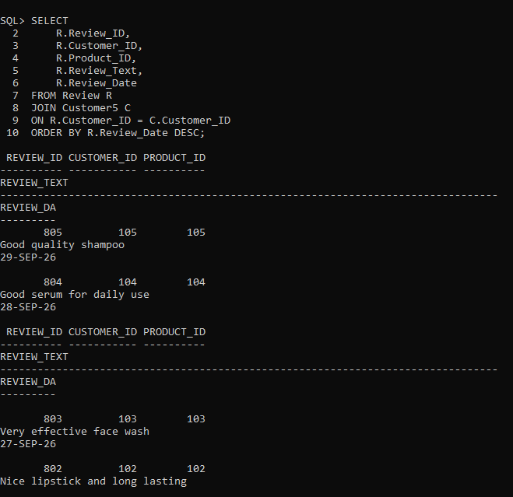

- Calculate Average Product Ratings

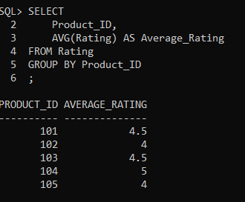
- Identify Highly Rated Products

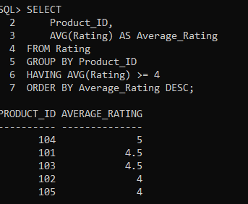

- Product Rating Report

